LAB ASSIGNMENT 6

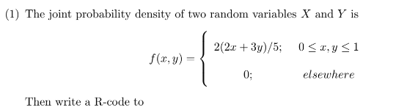

1. check that it is a joint density function or not? (Use integral2())

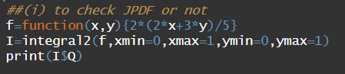

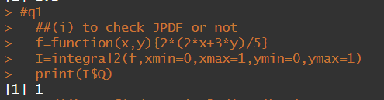

1. find marginal distribution g(x) at x = 1.

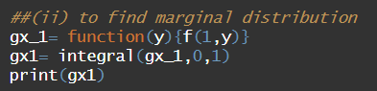

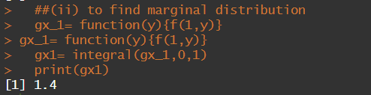

1. find the marginal distribution h(y) at y = 0.

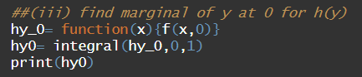

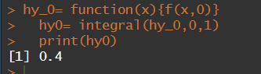

1. find the expected value of g(x, y) = xy.

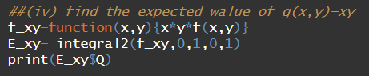

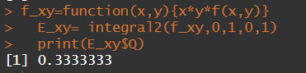

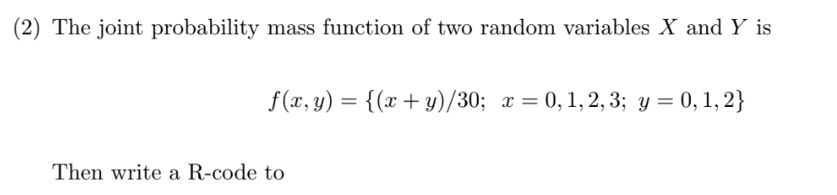

1. display the joint mass function in rectangular (matrix) form.

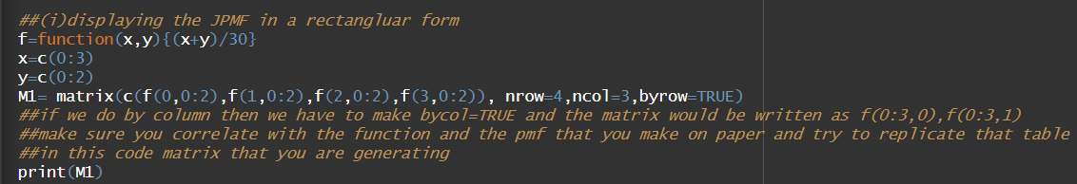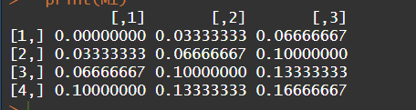

1. check that it is joint mass function or not? (use: Sum())





1. find the marginal distribution g(x) for x = 0, 1, 2, 3. (Use:apply())

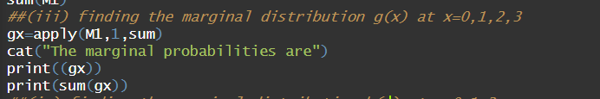

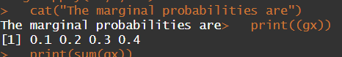

1. find the marginal distribution h(y) for y = 0, 1, 2. (Use:apply())

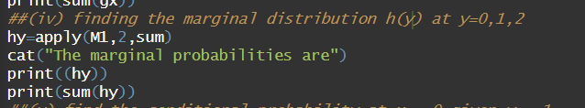

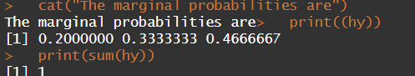

1. find the conditional probability at x = 0 given y = 1.

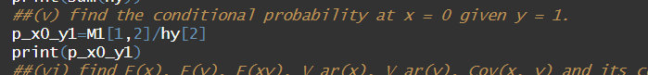

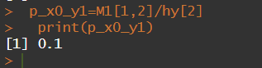

1. find E(x), E(y), E(xy), V ar(x), V ar(y), Cov(x, y) and its correlation coefficient.

